MIME 262 LECTURE notes 11th APRIL

Group 21

Gagne, Katie M.

Lee, Sooyeol

Prasad, Rohit

1. FLAWS AND DEFECTS IN SOLIDS

* POINT DEFECTS

Point defects are one dimensional that only occur around a single lattice point. They do not extend along any dimension. There are three main types:

**Vacancies:** a defect where an atom is missing from the lattice structure leaving a hole.

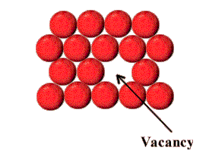

**Interstitial:** these occur when an atom occupies a site in the lattice structure where there isn’t suppose to be an atom. These defects are usually high energy configurations. eg: C in Fe.

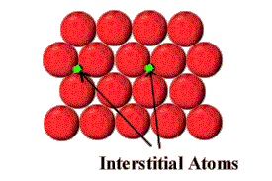

**Substitutional:** these defects occur when an atom not belonging to a particular material occupies a lattice position in that material. This atom may be larger than the host atoms hence causing strain on the lattice structure.

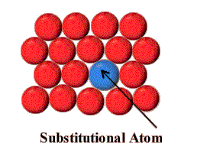

The equilibrium concentration of defects varies with temperature.

**ND/N = EXP (-Qp/KBT)**

**ND** is the number of defects

**N** donates the number of total atoms

**KB**and **T** represent the Boltzmann constant and the Temperature.

**-Qp**is the activation energy required for defects to occur. In the case of point defects this energy may be provided by the thermal vibrations of in the lattice structure. However thermal vibrations are not sufficient to cause line and planar defects.

* LINE DEFECTS

These defects occur along any single dimension of the lattice structure.

Dislocations are defects where some of the atoms of the crystal lattice are misaligned causing a part of a plane of the lattice structure to be misaligned relative to other lattice planes.

**Edge dislocations**: These defects occur when a half plane of atoms is introduced midway through the lattice structure.

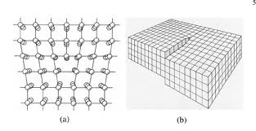

This type of dislocation can cause stress mismatches in the lattice structure where the upper half undergoes compression while the lower half has increased tension. These dislocations make it easier for a material to be deformed by applying a sheering force.

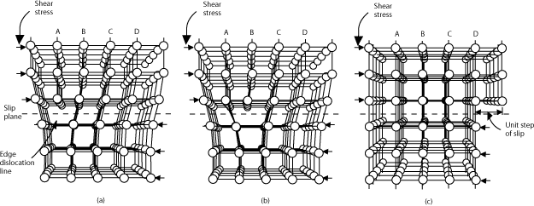

In the above diagram we notice that the crystal is locally deformed at the unit step of slip but in general it is globally perfect.

**Screw dislocations:** These dislocations are much harder to visualize. The motion of a screw defect is also a result of shearing forces but the defect line movement is perpendicular to the direction of stress and atom displacement.

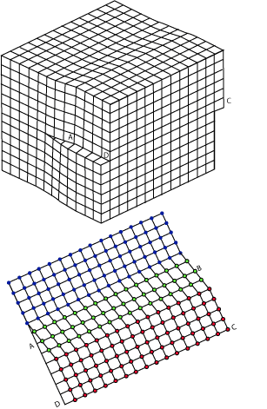

* PLANE DEFECTS

Such defects occur along surfaces and interfaces where unlike atoms in the bulk of the material, atoms on the interface are missing bonds.

**Grain boundaries:** a grain boundary is the interface between two grains or crystallites in a polycrystalline material. Such defects tend to reduce the electrical and thermal conductivity of materials. However grain boundaries also prevent other defects from moving across grain interfaces.

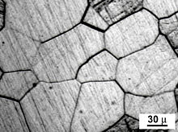

**Defects are a KEY to material properties**

In metals the movement of defects is a major factor determining the Yield Strength and the Ultimate Tensile Strength. Stressing a material beyond the yield strength causes motion of defects but stressing a material beyond the UTS causes too many defects leading to plastic deformation.

Methods of strengthening a material:

The idea is to make defects more resistant to motion under stress. In metals there a various methods of accomplishing this:

* **Reducing grain size.** By creating more grain boundaries one can limit the motion of defects across grain interfaces.
* **Reducing stress mismatch** (like those caused by edge dislocations). This can be achieved by adding large impurities in the regions under tension and smaller impurities in the regions under compression.
* **Precipitation hardening.** This is a method of heat treatment that produces fine particles of an impurity phase, which impede the movement of dislocations, or defects in a crystal's lattice. This technique is used in strengthening aluminium used in manufacturing aeroplanes.
* **Cold work.** `Massaging` a metal to cause numerous dislocations that multiply and get tangled up, restricting the motion of defects.

**FAILURE OF MATERIALS**

**Fracture failure:** causes large deformations in materials but it remains in one piece.

eg. In metals failure is preceded by deformations caused my tiny voids and bubbles that grow and eventually meet.

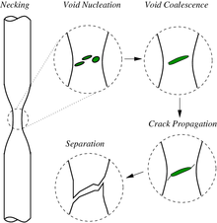

**Brittle failure:** causes the material to shatter in too many pieces due to numerous small deformations.

eg. In ceramics failure causes shattering as deformations spread through the materials.

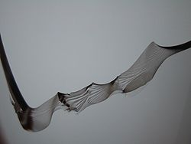

Figure :brittle fracture in glass

Even though ceramics are stronger than metals they are unreliable for most engineering purposes since brittle failure in ceramics is unpredictable.

**TOUGHNESS IN MATERIALS**

Toughness in materials is the ability to absorb energy and plastically deform without fracturing.

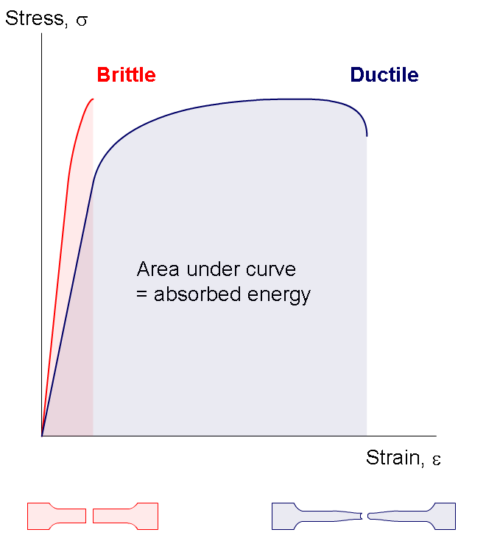

From the above graph we can see that even though ceramics are stronger than metals it takes a lot more energy (area under curve) to cause complete failure in metals.